EXPT : 4b | EXPLORATORY DATA ANALYSIS (EDA) – DATA INSPECTION, FILTERING, STATISTICAL ANALYSIS AND CORRELATION- Retail Sales Data
DATE :

AIM
To perform data inspection, filtering, grouping, aggregation, descriptive statistical analysis, and correlation analysis using Pandas and visualize the results using Matplotlib.
ALGORITHM
- Start and import the required libraries.
- Load the sales dataset and display its basic information.
- Check shape and data types of the dataset.
- Remove duplicates and handle missing discount values.
- Filter products based on price and category.
- Sort products according to UnitPrice.
- Create a bar chart for top 10 products.
- Calculate statistics such as mean, median, mode, and standard deviation.
- Calculate category and regional quantities and visualize them.
- Find correlations between numerical columns and stop.
CODE
import pandas as pd
df=pd.read_csv("C:/Users/ramya/Downloads/Retail_Sales_Raw (1).csv")

# Display first five rows
print(df.head())
# Display dataset dimensions
print(df.shape)
# Check column data types
df.dtypes
# Display high price products
high_price = df[df["UnitPrice"] > 450] # Filter high price products
print(high_price)
# Display laptops record
laptops = df[(df["ProductCategory"] == "Electronics") & (df["Product"] == "Laptop")]
print(laptops)
# Sort prices descending
sorted_df = df.sort_values(
by="UnitPrice",
ascending=False
)
print(sorted_df.head(10))
# Create bar chart top prices
import matplotlib.pyplot as plt
plt.figure(figsize=(10,5))
plt.bar( sorted_df["Product"].head(10), sorted_df["UnitPrice"].head(10))
plt.title("Top 10 Products by Unit Price")
plt.xlabel("Product")
plt.ylabel("Unit Price")
plt.xticks(rotation=45)
plt.show()
print("Mean =", df["UnitPrice"].mean()) # Calculate average price
print("Median =", df["UnitPrice"].median()) # Calculate middle price
print("Mode =", df["UnitPrice"].mode()) # Find common price
print( "Standard Deviation =", df["UnitPrice"].std())
# Calculate category average
category_avg = df.groupby("ProductCategory")["UnitPrice"].mean()
print(category_avg)
# Create line chart prices
plt.figure(figsize=(8,5))
plt.plot(
category_avg.index,
category_avg.values,
marker="o"
)
plt.title("Average Price by Category")
plt.xlabel("Product Category")
plt.ylabel("Average Unit Price")
plt.xticks(rotation=45)
plt.grid(True)
plt.show()
# Calculate quantity by region
region_sales = df.groupby(
"Region"
)["Quantity"].sum()
print(region_sales)
# Create bar chart by region
plt.figure(figsize=(8,5))
plt.bar(
region_sales.index,
region_sales.values
)
plt.title("Quantity Sold by Region")
plt.xlabel("Region")
plt.ylabel("Total Quantity")
plt.show()
# Calculate numerical correlation
corr = df[
["Quantity", "UnitPrice", "Discount"]
].corr()
print(corr)

OUTPUT

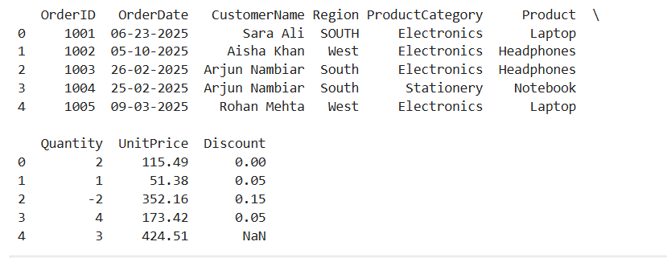

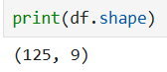

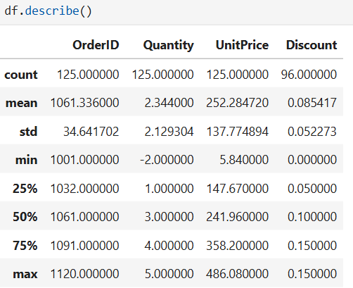
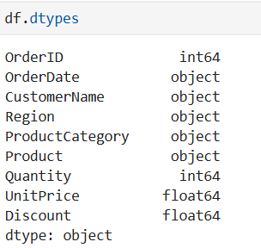

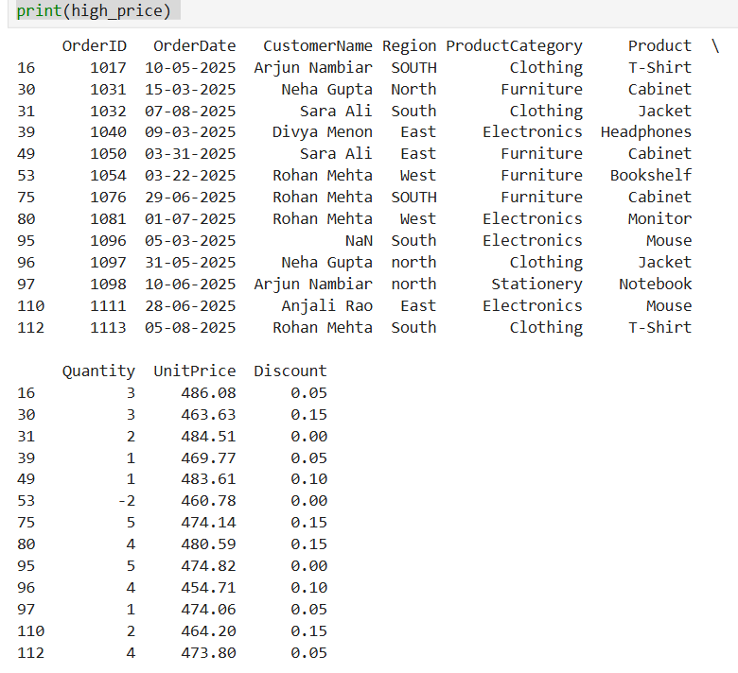
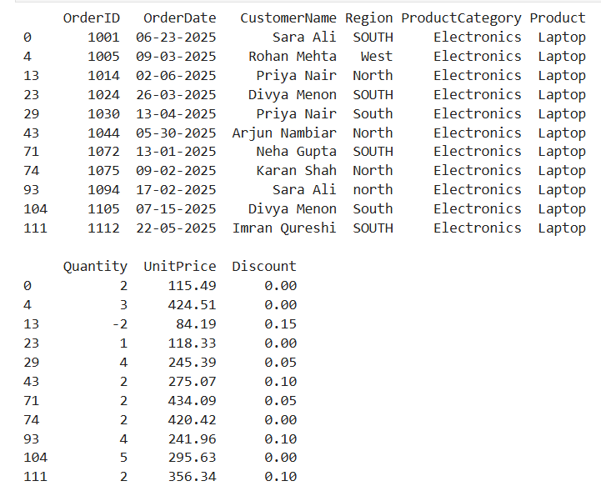

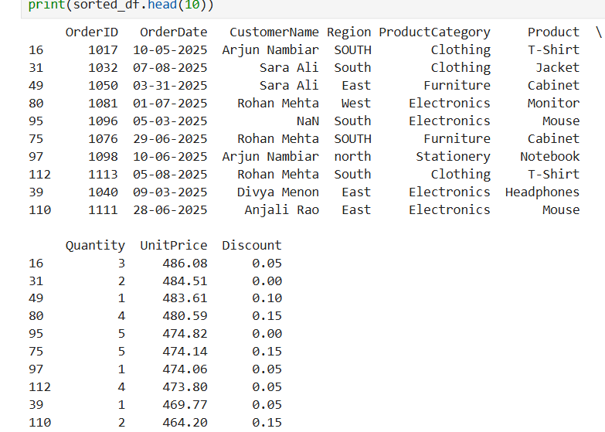

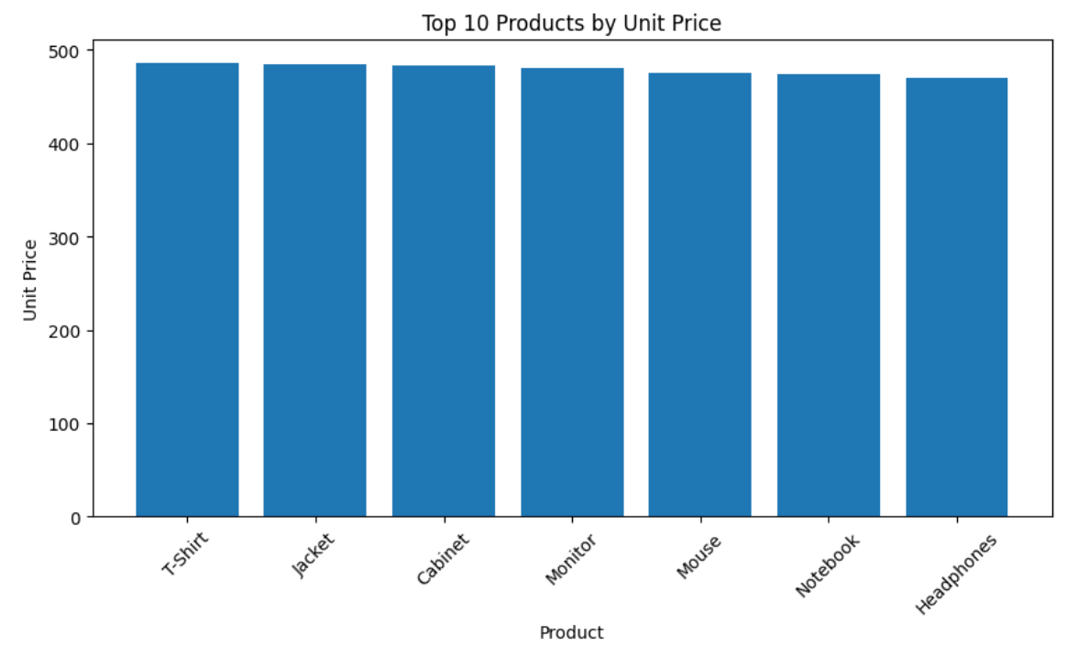

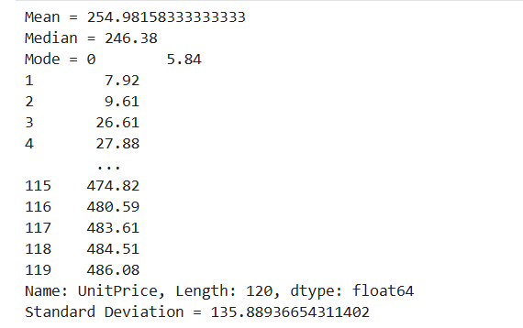

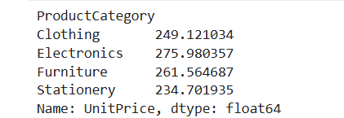

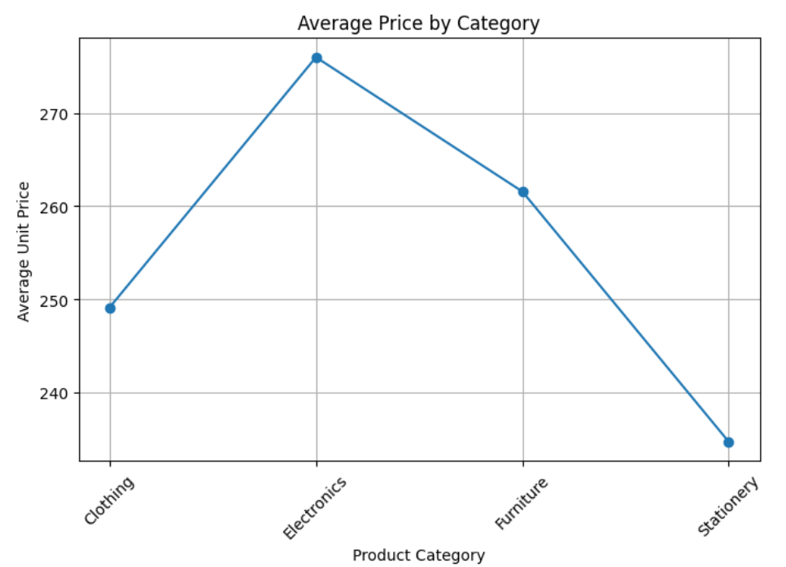
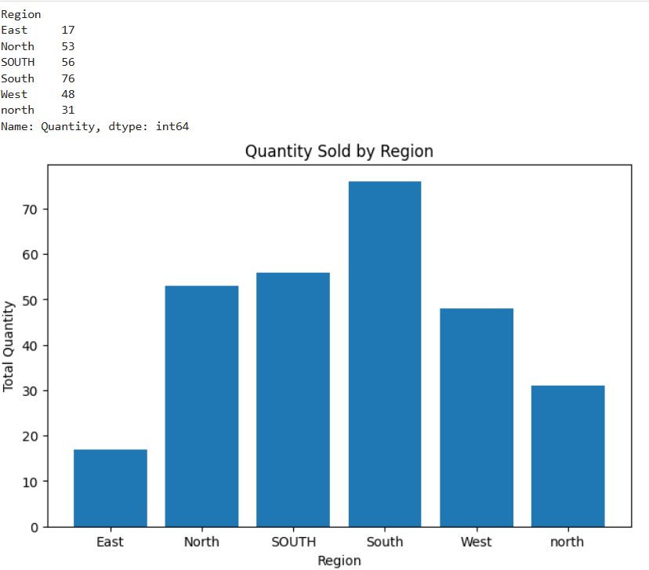

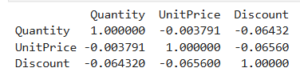

RESULT
Thus, data inspection, filtering, sorting, descriptive statistical analysis, grouping, aggregation, and correlation analysis were successfully performed using Pandas. The analytical results were visualized and interpreted successfully.

